- OVERVIEW OF PERIPHERALS THEORY
Device Category | Type | Real-Life Use Case
Printer | Inkjet Printer | Printing college assignments, project reports, and photos at home.
Printer | Laser Printer | Printing large volumes of documents quickly in offices and schools.
Printer | Dot Matrix Printer | Printing invoices, receipts, and multi-copy forms in banks and shops.
Scanner | Flatbed Scanner | Scanning certificates, photographs, and documents into digital format.
Scanner | Handheld Scanner | Scanning barcodes and product labels in supermarkets and warehouses.
Webcam | Built-in Webcam | Attending online classes, video calls, and virtual meetings on a laptop.
Webcam | External USB Webcam | Live streaming, online teaching, and high-quality video conferencing.
1.Create a table listing 3 types of printers, 2 types of scanners, and 2 types of webcams, and for each, write one real-life use case.

2.Draw a labeled diagram showing how a typical home printer connects to a laptop or PC, including the connection interface used (USB, Wi-Fi, or Bluetooth).
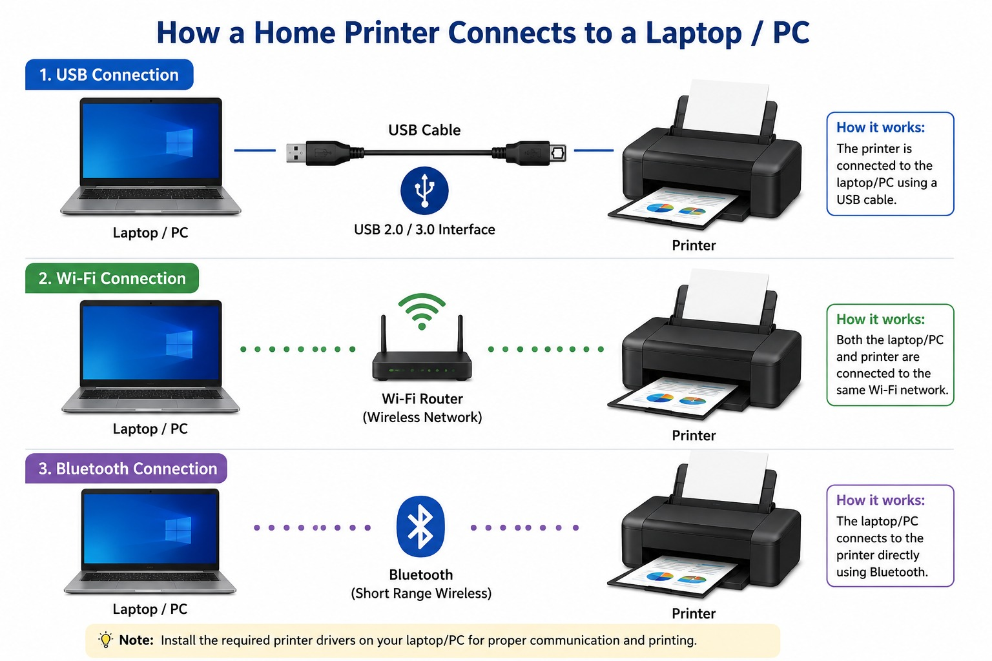

3.List three different connection interfaces (such as USB, Wi-Fi, Bluetooth) used by peripherals like printers, scanners, and webcams, and for each, name one advantage and one disadvantage.<br><br><em><strong>Hint:</strong> Think about speed, convenience, and compatibility.</em>
Connection Interface | Used In | Advantage | Disadvantage
USB (Universal Serial Bus) | Printers, scanners, webcams | Fast and stable connection with reliable data transfer. | Requires a physical cable, limiting device placement.
Wi-Fi | Wireless printers, scanners, webcams | Allows devices to connect without cables and can be used from multiple devices. | Connection speed and reliability depend on network quality.
Bluetooth | Webcams, printers, scanners, and other peripherals | Easy wireless connection with low power consumption. | Shorter range and generally slower data transfer than Wi-Fi or USB.

4.Pick any one device you use at home or college (printer, scanner, or webcam). Write step-by-step instructions for how you would connect it to your computer, including what cable or wireless method you would use and any setup steps required.
Connecting a Printer to a Computer (Using USB Cable)
Introduction
A printer is a common peripheral device used at home, college, and offices to produce hard copies of documents and images. The following steps explain how to connect a printer to a computer using a USB cable.
Step-by-Step Instructions
- Place the Printer
  - Place the printer on a stable surface near the computer.
  - Ensure that it is close enough for the USB cable to reach the computer.
- Connect the Power Cable
  - Plug the printer's power cable into an electrical outlet.
  - Turn on the printer using the power button.
- Connect the USB Cable
  - Connect one end of the USB cable to the printer.
  - Connect the other end to an available USB port on the computer.
- Wait for Device Detection
  - The computer should automatically detect the printer.
  - A notification may appear indicating that a new device has been connected.
- Install Printer Drivers
  - If the drivers do not install automatically, use the installation CD provided with the printer or download the latest drivers from the manufacturer's website.
  - Follow the on-screen instructions to complete the installation.
- Add the Printer
  - Open Settings > Bluetooth & Devices > Printers & Scanners (Windows).
  - Click Add Device and select the printer from the list.
- Print a Test Page
  - Open any document.
  - Select Print and choose the connected printer.
  - Print a test page to verify that the printer is working correctly.
Required Items
- Printer
- Computer or Laptop
- USB Cable
- Power Cable
- Printer Drivers (if required)
Conclusion
By following these steps, a printer can be successfully connected to a computer using a USB cable. Once installed, the printer can be used to print assignments, reports, photographs, and other documents quickly and efficiently.

